Documentation for Cleaning and Preparing the Data:

**Task Includes:  
Adjusting column widths  
Removing Blank spaces  
Removing Duplicates  
Checking for spelling Errors  
Trimming white spaces  
Converting the table into Pivot format  
Merge multiple columns with the same title into one column.**Steps Involved: **Step 1**: Upload the file into Excel by **Get External data** from **Data Tab.**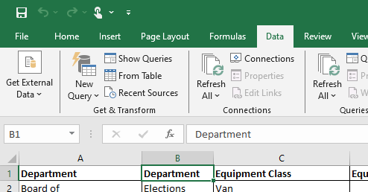

2. Choose the file and click on Upload.  
Covert the file into XLS format if the input file data is in CSV or any other format.  
If the file is in CSV format. Use delimiter and select tab and comma separated and click on finish to Load.

Step 2: Once the file is uploaded. Perform the Task 1. **Adjusting column widths  
Adjust the column width by selecting** CTRL+SHIFT+RIGHT and double click on one of the columns. Remaining columns will be automatically adjusted.

**Step 3: Removing blanks Spaces**To Remove blank spaces Select filter on one of the column and filter with blanks. Once all the blank rows are displayed. Select the blank rows and delete.   
If only one column is blank in a row. Fill with the appropriate value.

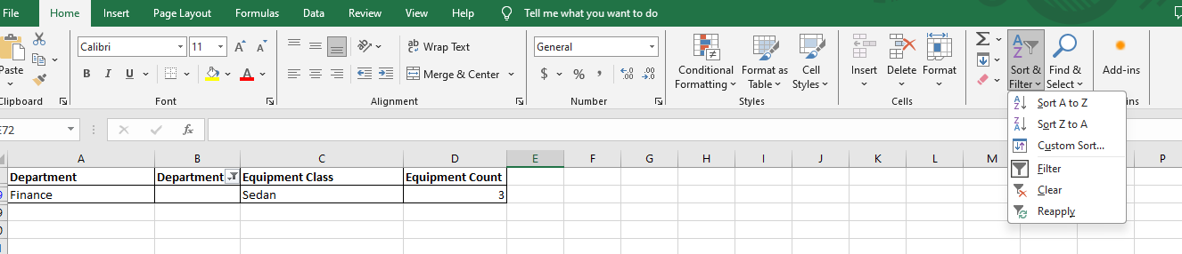

In the above case finance department, we can fill the value with the office. As office is an appropriate value for finance department.

Step 4: **Removing Duplicates  
Select entire tab and select remove duplicates from Data Tab.**

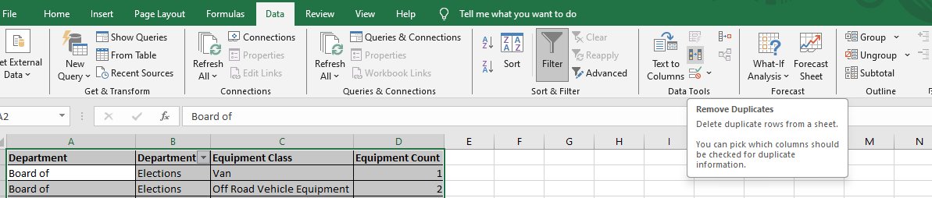

Ensure they are duplicates before deleting.

Step 5: **Checking for spelling Errors**

**Select Spelling check under Review Tab. If there are any spelling mistakes Excel will let us know.**

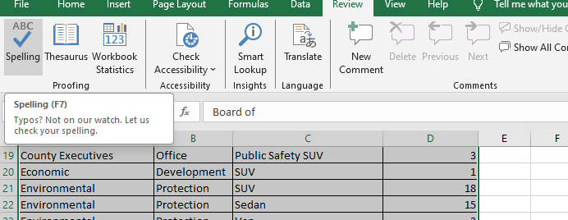  
Step 6: **Trimming white spaces**

**Look for double spacing. Select all the tabs and Press CTLR+F. Select find and replace. Insert double space “ ” in the find tab and on replace tab select “ ”. Select Replace all.**

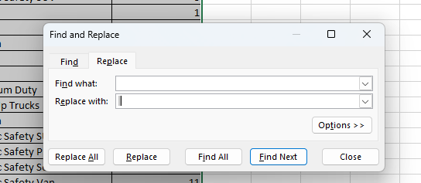

Step 7: Merging multiple columns into one.  
Find out multiple columns which contains similar column names.  
By using =CONCATENATE (A1,” ”, B1) separated by space or by using flashfill in the data tab we can merge two columns into one.  
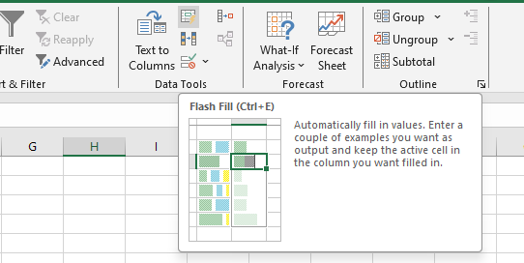

Step 8: Used Formulas to calculate Sum, Average, Max and Min  
  
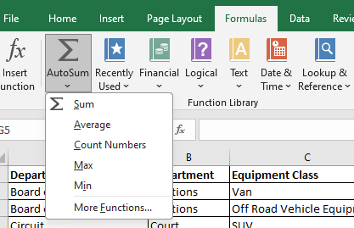

Step9: Once the data is cleaned convert that data into Pivot table for visualization.  
For converting the data into pivot tables. Select pivot tables from Insert tab.  
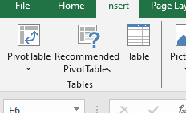  
Arrange the columns accordingly.

